**SEZ UNIT**

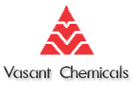

**Internship Report**

**Submitted by- Mentored by-**

Shashank Shekhar Mr. Ramakrishna Iyer

Suddapalli Sandeep (V.P. Operations)

Y. Sivaiah Naidu Mr. S. Joseph

Chemical Engineering, IIT (BHU) (G.M. Operations)

**Acknowledgement**

We have taken efforts in this internship. However, it would not have been possible without the kind support and help of many individuals. We would like to extend our sincere thanks to all of them.

We are highly indebted to Mr. Ramakrishna Iyer for his guidance and constant supervision as well as for providing necessary information regarding the plant & also for his support in completing the project.

We would like to express our gratitude towards Mr. S. Joseph for his kind co-operation and encouragement which helped us in completion of this Internship.

We would finally like to express our special gratitude and thanks to all the employees of Vasant Chemicals Pvt. Ltd. for giving us such attention and time.

Shashank Shekhar

Y. Sivaiah Naidu

Suddapalli Sandeep

**INDEX**

|  |  |
| --- | --- |
| 1. Safety | 4 - 7 |
| 1. Stores | 8 - 9 |
| 1. Boiler | 10 - 12 |
| 1. Chiller Plant | 13 - 15 |
| 1. Nitrogen Plant | 16 - 17 |
| 1. MEE, ATFD | 18 - 19 |
| 1. Biological Treatment Plant | 20 - 21 |
| 1. Projects | 22 - 23 |
| 1. Production | 24 - 27 |
| 10.Suggestions | 28 - 30 |

**General Safety Protocol and Stores**

**Safety**:

***“Working safely may get old, but so do those who practice it”***

Safety is one of the vital parts of any chemical production plant. Safety has various aspects in a chemical plant namely,

**Fire:**

Fire hazards are the most common and one of the most dangerous hazards in a chemical industry.

In case of major fire, employees are expected to leave the premises and assemble at assembly points for further instructions.

For minor fire, it is classified on the basis of its fuel. All together there are four classes of Fire. A, B, C and D.

|  |  |  |
| --- | --- | --- |
| **Description** | **Class** | **Fire extinguisher** |
| Combustible material (wood, paper etc.) | A | Water |
| Flammable liquids (petroleum, solvents etc.) | B | Foam |
| Gases (LPG etc.) | C | Co2 |
| Flammable metals  (Sodium, potassium etc.) | D | Dry chemical powder (DCP) |

For Class A, Fire water is used in the fire extinguishers. Similarly for B, C and D type fire, foam (NaHCO3), CO2 and dry chemical powder are used respectively.

For using fire extinguisher a simple acronym “**Pass**” can be remembered which means,

P – PULL

A - AIM

S – SQUEEZE

S – SWEEP

Vasant chemicals also has a full-fledged fire hydrant system in the plant. It has a 380KL water storage tank with a jockey, main and diesel pump for circulating the water when needed.

In case of power cut, diesel pump are used for firefighting purposes

The main pump has a capacity of 270 KL per hour thus providing in house firefighting 1.5 hours.

**Personal Protective Equipment’s**:

For the protection of employees and contract labor, this safety equipment plays an important role. Some of these equipment’s are;

1.      Helmets

2.      Nose Masks

3.      Shoes

4.      Chemical Goggles

5.      Ear plugs

6.      Chemical suits etc.

**Safety Policy**:

Vasant Chemicals has laid various safety rules for their employees and contract labor. Few of the Safety rules are as follows:

1.      For transferring of fluid from one container to another container earthing should be done to avoid fire.

2.      Safety equipment should be used at all times inside the production plant

3.      Touch pads are installed in production blocks and warehouse to lay off the static charge induced in the workers.

4.      All the SOP’s (Standard operating procedure) must be followed.

5.      In case of chemical contact with eyes, eye wash fountains must be used immediately which are installed at many places.

6.      Water sprinkling systems are installed near the raw material storage tanks & solvent yard to avoid fire.

7. All the employees must have proper training and information about all the physical or health hazards in order to avoid them



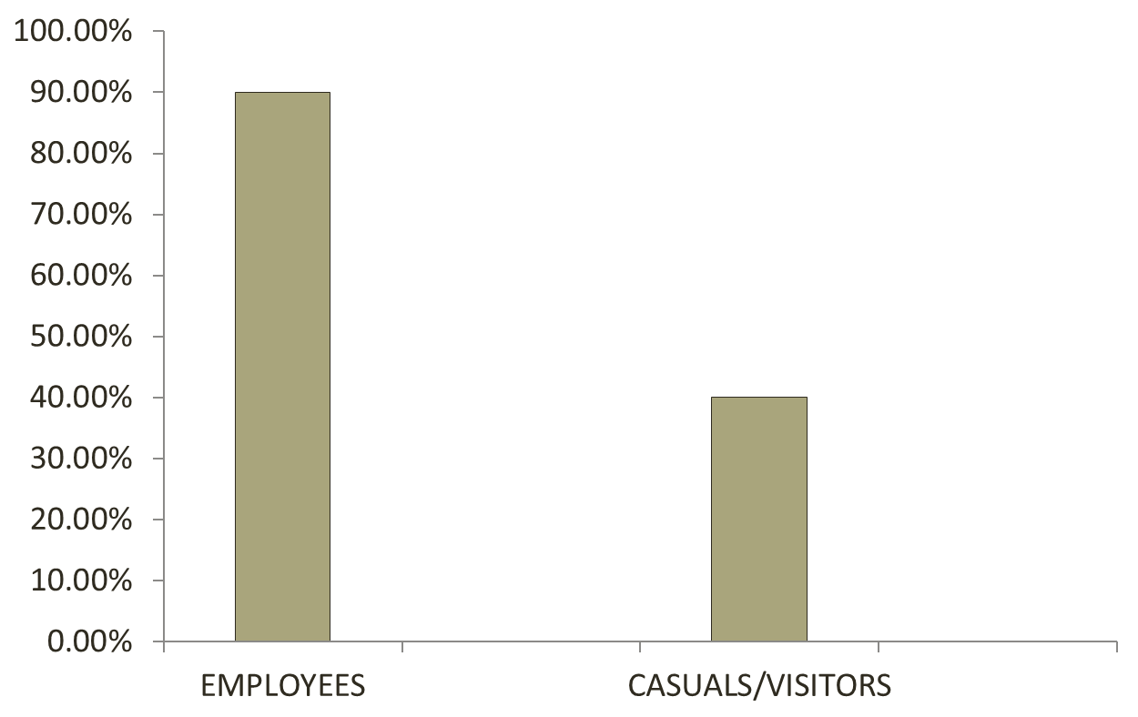

This Survey shows the percentage of people (Workers and employees) who are aware of basic safety protocols

**STORES**

Stores can be classified into two types (In Vasant chemicals).

1.      Chemical warehouse

2.     Engineering Stores

**Chemical Warehouse**:

1 This warehouse stores products, raw materials and other chemicals required for production.

2 When any raw material arrives at the warehouse, it is received by warehouse person and kept in Quarantine area until it is checked by Quality control (QC) department.

3 Only after testing if the material is approved QC will give approved label then only the material will be issued for production.

4 If the material is got rejected this will be sent back to supplier for replacement.

**Engineering Stores:**

1 It stores all the engineering items required for Vasant chemicals.

2 A proper standard operating procedure is followed in this warehouse. First indent will be raised for required material by user department, and it is verified by HOD of user department and then sent to accounts department for budget.

3 If it exceeds the budget, it will require approval by the senior officials.

4 The indent will be sent to warehouse for verification of details to avoid any mistakes.

5 Now it is sent to procurement department for price negotiation with vendors after that a purchase order is generated and set to purchase department.

6 After arrival of the purchased material, it is verified by user department and material will be checked against the purchase order for meeting specification.

7 A Goods receipt note will be generated by the stores. In case of taxable items, ARE is prepared to get the subsidy on tax paid (Special Economic Zone).

8 Purchase department will update quantity, cost, material, vendor name on tally by taking PO as reference number after receiving the Goods from vendor, GRE/ARE is updated in the Tally by taking PO as reference number.

9 Then the following GRE will be verified, After verification payment will be done to the vendor with GRE reference number. Apart from Tally, there will be a hard copy maintained in the stores for accounting purpose.

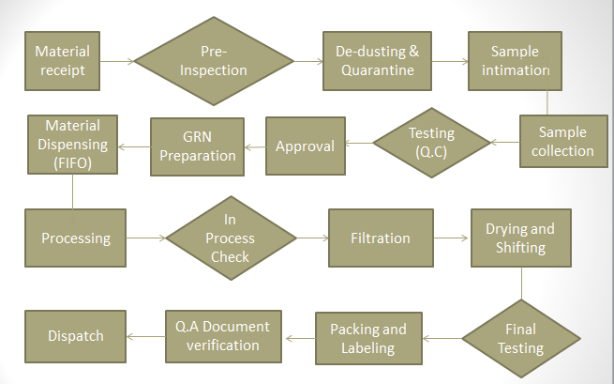

**BOILER**

There are two types of Boilers in our plant.

1 Thermax 6 Ton Boiler

2 Thermax 3 Ton Boiler

It provides steam to the entire plant by boiling the water with the help of Coal.

1. The 6 Ton Boiler is a Fluidized bed where bed is made of silica, sand etc.
2. It is a 2 step bed where air distributor plates are installed to provide preheated air (Air is heated by the leaving flue gases) as fluidizing medium.
3. Here water is there in the tubes above the bed (water tube) which absorb heat to convert into steam.
4. The flue gas is now passed in the tubes through a tank of water (Fire tube) to again vaporize water.
5. This flue gas now pre heats the air passes through cyclone separator and bag filters to lay off particulate matter and leaves through the chimney.

**Operation**

1. The coal is first crushed into 0.5- 1.5 mm size by pulverizer and sent to the beds.
2. The beds are replaced every few hours with separate sand.
3. The bed is ignited by using Diesel soaked charcoal which gives thick smoke initially.
4. Various safety valves are installed to avoid high steam pressure (10Kg/cm2).

**Calculations**

Let the mass of coal charged be Mc

Let the mass of Steam be Ms

Calorific value of coal used is 4000 Kcal/Kg Approx.

Pressure 9 Kg/cm2

Enthalpy of steam at 9kg/cm2 175°C is 2774.22 KJ/Kg

Water coming at temperature 32°C

Enthalpy 155.5 KJ/Kg

Ms (2774.22-155.5) = Mc (4000*4.184) {4.184-Conversion factor}

6000(2774.22-155.5) = Mc (4000*4.184)

Mc = 938.8 ( Kg/hr Theoretical)

Mc = 1200.0 (Kg/hr Actual )

**Efficiency = 78.2 %**

Steam to Coal Ratio 6.39 (Theoretical)

5 (Actual)

If 15% Excess Air is used, then

78 moles N2 21 moles of O2

3.7143 moles N2 1 mole of O2

C + O2 CO2

Flue Gas: (For 15% excess air)

1 mole CO2

4.271428 moles N2

0.15 moles O2

Giving = (0.15x 100)/ 5.4214=**2.77 % O2**

Flue Gas: (For 20% excess air)

1 mole CO2

4.45716 moles N2

0.2 moles O2

Giving = (0.20x 100)/ 5.4214=**3.69 % O2**

Oxygen in Flue Gas is **2.8 to 3.7 %**

**Chiller Plant**

1. It uses Ammonia (717) as refrigerant. Here Ammonia goes in a refrigeration cycle i.e one compression one expansion and an evaporation and condensation steps.
2. It is a two stage chilling plant which also uses a inter cooler.
3. In the condenser it uses RT water to condense Ammonia.
4. After expansion I is sent to Chiller where 45 % W/W methanol brine from the hot tank is cooled.
5. The chiller plant is nothing but a refrigerator with ammonia receiver which extracts the heat from hot tank after its expansion.
6. An estimation of TR (Ton of refrigeration) was also done. As brine from the hot tank and the cold tank has a temperature difference of 6°C.
7. The brine comes in at about 35 m3/hr.
8. At that temperature as the brine has density of 937.5 Kg/m3 and Specific heat capacity of about 2.95 KJ/Kg

SO, (**For PB2**)

TR = mCpΔT / 3.5 KW

= ((35m3/hr * 937.5 Kg/m3 * 1 hr* 2.95 KJ/KgK *6 K)/ 3600 Sec )/ 3.5 = 46.1 TR

The ideal TR should have been 50TR which could be accounted to the friction loss in pipes as well as heat transfer to atmosphere

When a single compressor is running,

TR = mCpΔT / 3.5 KW

= ( (35m3/hr * 937.5 Kg/m3 * 1 hr* 3.01 KJ/Kg K *3.5 K)/ 3600 Sec )/ 3.5 = 27.4 TR

**Single Compressor 27.4 TR**

**Both Compressor 46.1 TR**

**Troubleshooting (Chiller plant)**

1. **Treat condenser water:**

Chiller efficiency declines rapidly when tubes become fouled. Contaminants, such as minerals, scale, mud, algae and other impurities, increase thermal resistance and reduce overall performance. These contaminants accumulate on the water side of heat transfer surfaces in both closed- and open-loop systems. Fouling occurs gradually over time, depending on the quality and temperature of the water used.

Condenser tubes should be brush cleaned, rather than chemically cleaned, at least annually with an automatic rotary-cleaning machine to keep them free of contaminants.

1. **Reduce entering water temperature:**

Lowering the temperature of the water entering the condenser can improve the chiller's efficiency. On some building systems, operators can reduce the chilled water set point to overcome air handler deficiencies such as dirty coils. Beware of this practice, which may stop the symptoms but won't cure the problem. It makes the chiller work harder for the same net cooling effect.

1. **Control water velocity:**

Flow rate must be regulated closely, because too low a flow rate reduces chiller efficiency, leading to laminar flow. The minimum flow rate is typically around 3 ft. per second. However, too high a flow rate leads to vibration, noise and tube erosion. The maximum recommended flow rate is typically around 12 ft. per second.

1. **Maintain refrigerant charge**:

The amount of cooling that any chiller can provide depends on how much refrigerant it moves through the compressor per unit time. It's important to maintain the proper level of refrigerant.

Leaks, as well as air and moisture, decrease efficiency and system reliability. Low refrigerant charge, usually resulting from leaks, causes the compressor to work harder and achieve less cooling effect.

1. **Purge non-condensables:**

Air and moisture are two non-condensables that can leak into low-pressure chillers. Non-condensables can reduce chiller efficiency by as much as 4% at 60% load and 7% at 100% loads.

**Nitrogen plant**

**Product gas specifications**:

1. Capacity : 20 NM3/HR. N2 gas
2. Oxygen contents : 0.5% (MAX)
3. Gas Temperature : Ambient
4. Gas pressure : 5.0 Kg/cm2 g (MAX)

**Process description:**

PSA nitrogen generators are based on well proven technology  
using carbon molecular sieves (CMS). Carbon molecular is an adsorbent having infinite number of small pores and having a property of preferential adsorption of oxygen molecules.  
Therefore, the nitrogen is recovered to a high degree whilst almost all the oxygen is adsorbed.

This compressed air at 7.0kg/cm2 g from air receiver is passed through A twin tower PSA module through pre filter where the air first get dried and then it is passed through carbon molecular sieves where oxygen, co2  and moisture are selectively adsorbed. The unadsorbed gas which is mainly nitrogen comes out and goes to nitrogen surge vessel. The nitrogen gas generator consists of two towers. Both the towers are filled with a bed of carbon molecular sieves over a layer of activated alumina. At a time, one tower remains in cycle while the others undergo regeneration by pressure swing principle I.E by desorbing to atmosphere at low pressure.

The adsorbers keep switching automatically by a PSA timer and nitrogen gas with better than 99.5% purity is continuously produced and goes to the nitrogen surge vessel. The pressure swing process is run with fixed cycle times. Total cycle times for adsorption and desorption is of 2x65 seconds. The flow of feed air and flow/ concentration control of product gas is assured solely by the manual valves air inlet valves, product outlet valve and their setting should not be disturbed.

The nitrogen from the surge vessel goes to nitrogen receiver through rotameter and back pressure controller at 20 NM3/Hr. flow & 5.0 Kg/cm2g pressure.

**Calculations:**

Nitrogen is produced by this plant at a rate of 20Nm3/hr

=

**=8.4 x 10-4 m3/sec**

**Multiple effect evaporator & ATFD**

**General description of the plant:**

**MEE**

Feed Is received in a level controlled balance tank and passed backward through pre-heaters using vapour from preceding effect as heating medium. Pre-heated feed is then fed to the 1st effect calandria. It is uniformly distributed in the calandria top so that liquid falls inside the tube area in the form of thin film. Dry saturated steam/vapor is supplied as heating medium in the jacket which causes evaporation of water from feed liquid in the calandria vapors generated are separated in 1st vapour separator and passed into the jacket of 2nd effect calandria as heating medium. Concentrated product from the 1st is feed to calandria of 2nd effect. it then it passes through all the effect to meet its final required concentration. Product with desired solid content from last effect is taken out. Vapors from last effect are condensed in surface condenser. All the evaporation effects operate under vacuum maintained by vacuum pump system. The concentrated product at the desired concentration is continuously taken out from the plant.

To lower the steam utility consumption, TVR (thermal vapour recompression) system is used. Part of vapours from intermediate effect is thermally recompressed by motive steam and mix flow is given in the jacket to 1st effect of evaporator.

**ATFD**

Concentrated product received from the evaporation plant is fed to the Agitated thin film dryer at the dryer shell which is arranged agitated position. Feed is uniformed distributed over the inner heat transfer surface to form thin film of product by the continuous agitator type scrapper blades specially designed for the requirement. Steam is provided in the outer shell. Vapours generated are taken out by vacuum pump/ID fan. Dried product comes down from the heat exchanger inner shell surface. The dried product is at 8-10% moisture

**Calculations:**

$$WE=F ×\left(1- \frac{Sf}{Sc}\right)$$

Where,

F = feed rate (kg/hr)

C = concentrate quantity (kg/hr)

Sf = Solids in feed (%)

Sc = Solids in concentrate (%)

WE= water Evaporation (kg/hr)

WE = $1950×\left(1-\frac{18}{34.5}\right)$

WE=932.608 kg/hr

**Efficiency = $\frac{932.608}{1700}×100$**

$≈55\%$

Similarly, for ATFD

$$WE=F ×\left(1- \frac{Sf}{Sc}\right)$$

WE = $200×\left(1-\frac{34.5}{90}\right)$

WE=123.33 kg/hr

**Efficiency = $\frac{123.33}{147}×100$**

$$≈83.9\%$$

**Biological Treatment Plant**

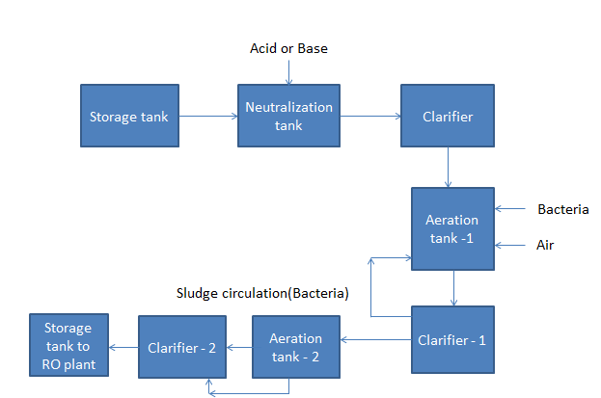

Fig. Flow chart for Biological Treatment plant

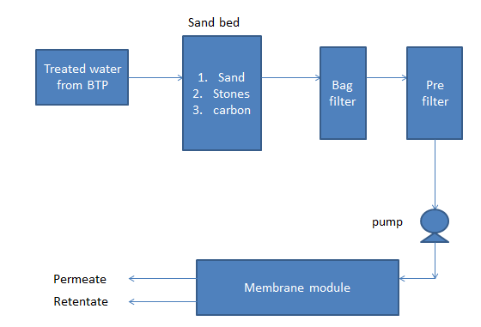

**Operation:**

1. Activated sludge is a biochemical process for treating sewage and industrial wastewater that uses air (or oxygen) and microorganisms to biologically oxidize organic pollutants, producing a waste sludge (or floc) containing the oxidized material. In general, an activated sludge process includes:
2. An aeration tank where air (or oxygen) is injected and thoroughly mixed into the wastewater.
3. A settling tank (usually referred to as a clarifier or "settler") to allow the waste sludge to settle. Part of the waste sludge is recycled to the aeration tank and the remaining waste sludge is removed for further treatment and ultimate disposal.

**Projects**

* User Requirement Sheet:

1. Which type

2. Suitable MOC

3. Operating hours

4. Utilities required

5. Other requirements (nozzle size etc.)

* After receiving URS, we will get the quotation from vendors. In quotation we will check :

1. Equipment quality

2. Delivery date

3. Specification will meet or not?

4. Cost

**Qualification:**

* 1. Design Qualifications:

Capacity, MOC, Shell diameter etc.

* 2. Installation Qualifications:

Installation will done based on design

* 3. Operational Qualification:

Equipment's (Nozzles, valves, reactor etc.) checking at design specifications

* 4. Performance Qualification:

Trail runs will do

**Standard procedure for Projects:**

* PLF (Details of project, purpose of project, Target date, cost)
* Material estimation/Equipment cost/ Labor cost
* After raising PLF, will get approval from MD.
* After getting approval, indent will raise.
* Purchase Order
* GRN
* Project Execution
* Handover to UR department

**Production**

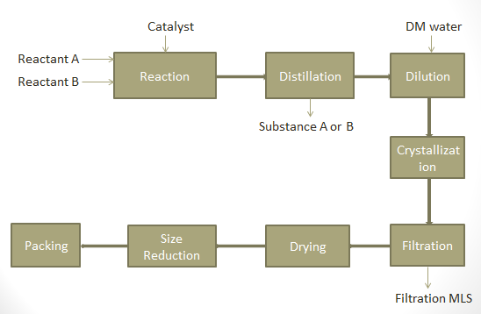

* **Filtration Equipment:**

1. Pressure nutch filter(PNF)

2. Agitated nutch filter(ANF)

3. Centrifuge

4. Leaf filter

5. Box filter

* **Drying Equipment:**

1. Tray vacuum dryer(TVD)
2. Rotary vacuum dryer (RVD)
3. Spray dryer

* **Reactors**

1. Glass lined reactor
2. Stainless steel reactor

* **Utilities**

1. Chiller Plant
2. Boiler
3. Nitrogen plant
4. Cooling Tower
5. Electricity

**Production planning:**

* At the beginning of the last weeks of month, marketing team provides a tentative dispatch schedule for the following month.
* Manufacturing in charges identify the production capacity of each unit based on the dispatch schedules, plant maintenance and breakdowns.
* Manufacturing in charges will review the dispatch schedule, confirm the same based on the monthly production plan, stock of the product and inform to the marketing team.
* Marketing team inform to the relevant customers about the amended dispatch dates.
* Production planning can be classified as:

1. Input planning

2. Output planning

* Input planning : Frequency of batch
* Output planning: Total duration of batch (output)
* R & D will provide tech pack, based on this production in charges will prepare BPCR. If process needs any improvement after formation of BPCR, they will take CCF.
* Formed BPCR will approved by QA department.
* Based on the BPCR production employee will feed the raw materials and note the readings (time, temp. etc.).
* Again QA will approve the final BPCR.
* **DISPATCH**

**Calculation:**

**Yield:**

* X Product:

Batch Size = 500 kg (Raw Material)

Theoretical Product = 121.17 kg

Actual Product = 118 kg

Yield(theoretical) = $\frac{121.17 kg}{500 kg}$ = 0.24

Yield (practical) = $\frac{118 kg}{500 kg}$ = 0.236

* Y Product:

Batch Size = 200 kg (Raw Material)

Theoretical Product = 147 kg

Actual Product = 130 kg

Yield (actual) = $\frac{130 kg}{200 kg }$ = 0.65

Yield (theoretical) = $\frac{147 kg}{200 kg }$ = 0.735

**Suggestions:**

1. Smell removal from **MEE or PB1**: Bio filter, exhaust system (proper ventilation).
2. **Production:**

* Use ball mills for reducing lumps (Size reduction).
* Granular Activated Carbon (GAC) can be regenerated. So we can use GAC in process.

1. **MEE**:

* Most of the receivers in MEE plant are leaking or overflowing which leads to very unhealthy workplace.
* Operators are not using mask near ATFD which may lead to severe health issues

1. Flocculants removal can be possible by polyelectrolytes in **BTP**.
2. **Chilling plant**: Fouled tubes, leaking refrigerant.
3. **Cooling towers:**

* Better cooling tower control by Minimizing blow down monitoring conductivity.
* PH/alkalinity control to minimize scale formation.
* Decreasing feed hardness, iron, and silica.
* Manage microbial growth.
* For blow down, post treatment in the form of reverse osmosis or ion exchange can prove extremely beneficial.

1. **Boilers:**

* Wet Coal: Wet coal decreases the efficiency of Boiler to a huge extent. A proper storage of coal should be done. An underground storage could be possible with conveyor belts (Already installed).
* Particle Size: For proper working of bed, coal should be in the region of Geldart A to B which has a size of < 0.5 mm. As observed particle size is much greater.
* Excess Air : There is no proper bench mark for excess air. More excess air will absorb sensible heat while low value would give suit. A 15% excess air is usually suitable for boiler

1. **Nitrogen Plant:**

* Flow meter which is installed in Nitrogen generation plant showing 28 Nm3/hr while its capacity is 20 Nm3/hr. One reason could be the malfunctioning of CMS which could have resulted in low purity of nitrogen. As the flow meter is calibrated for nitrogen, it is showing higher flow rate for relatively higher massed oxygen.

1. **RO plant :**

* Avoid chlorine in water (because will damage the polyamide membrane).
* Membrane regeneration by using citric acid.
* Activated carbon regeneration (by using steam).
* Silver impregnated Activated carbon.
* Ion exchange beds for decreasing hardness.

1. Use of genuine software for all the activities especially Microsoft Windows® operating system and Microsoft office® as they come with latest security updates.
2. Using a standard layout scheme in the warehouses for better material movement and ease of identification.
3. All the systems in the plant are prone to malware and due to network sharing spreading of malware will be high effecting the systems present in the Head office, so a good Antivirus software like Quick heal, Avast or AVG must be used in every system
4. We can use Critical Path Method (CPM), PERT analysis for executing proper project management. By using these methods, we can reduce project cost and time duration
5. Most of the employee doesn’t have the technical knowledge of instruments which leads to problems in the plant.